UNITED STATES
SECURITIES AND EXCHANGE COMMISSION
Washington, D.C. 20549
_________________
FORM 8-K
_________________
CURRENT REPORT
Pursuant to Section 13 or 15(d)
of the Securities Exchange Act of 1934
Date of Report (Date of earliest event reported): February 25, 2021
_______________________________

TPI COMPOSITES, INC.
(Exact name of registrant as specified in its charter)
_______________________________

Delaware | 001-37839 | 20-1590775
(State or Other Jurisdiction of Incorporation) | (Commission File Number) | (I.R.S. Employer Identification No.)
8501 N. Scottsdale Rd, Gainey Center II, Suite 100
Scottsdale, Arizona 85253
(Address of Principal Executive Offices) (Zip Code)
(480) 305-8910
(Registrant's telephone number, including area code)
Not applicable
(Former name or former address, if changed since last report)
_______________________________
Check the appropriate box below if the Form 8-K filing is intended to simultaneously satisfy the filing obligation of the registrant under any of the following provisions:

☐ | Written communications pursuant to Rule 425 under the Securities Act (17 CFR 230.425)
☐ | Soliciting material pursuant to Rule 14a-12 under the Exchange Act (17 CFR 240.14a-12)
☐ | Pre-commencement communications pursuant to Rule 14d-2(b) under the Exchange Act (17 CFR 240.14d-2(b))
☐ | Pre-commencement communications pursuant to Rule 13e-4(c) under the Exchange Act (17 CFR 240.13e-4(c))
Securities registered pursuant to Section 12(b) of the Act:

Title of each class | Trading Symbol(s) | Name of each exchange on which registered
Common Stock, par value $0.01 | TPIC | NASDAQ Global Market
Indicate by check mark whether the registrant is an emerging growth company as defined in Rule 405 of the Securities Act of 1933 (§230.405 of this chapter) or Rule 12b-2 of the Securities Exchange Act of 1934 (§240.12b-2 of this chapter).
Emerging growth company ☐
If an emerging growth company, indicate by check mark if the registrant has elected not to use the extended transition period for complying with any new or revised financial accounting standards provided pursuant to Section 13(a) of the Exchange Act. ☐

Item 2.02. Results of Operations and Financial Condition.
On February 25, 2021, TPI Composites, Inc. (the Company) issued a press release announcing its financial results for the three months and full year ended December 31, 2020. A copy of the Company's press release is furnished herewith as Exhibit 99.1 to this current report on Form 8-K and is incorporated by reference herein. The Company also posted a presentation to its website at www.tpicomposites.com under the tab "Investors" providing information regarding its results of operations and financial condition for the three months and full year ended December 31, 2020. The information contained in the presentation is incorporated by reference herein. The presentation is being furnished herewith as Exhibit 99.2 to this current report on Form 8-K. The Company's website and the information contained therein is not part of this disclosure.
The information in Item 2.02 of this current report on Form 8-K (including Exhibits 99.1 and 99.2) is being furnished and shall not be deemed "filed" for the purposes of Section 18 of the Securities Exchange Act of 1934, as amended, or otherwise subject to the liabilities of that Section. The information in Item 2.02 of this current report on Form 8-K (including Exhibits 99.1 and 99.2) shall not be incorporated by reference into any registration statement or other document pursuant to the Securities Act of 1933, as amended.
Item 9.01. Financial Statements and Exhibits.
(d) Exhibits
99.1 – Press Release dated February 25, 2021
99.2 – Presentation dated February 25, 2021
104 – Cover page Interactive Data File (embedded within the Inline XBRL document)

SIGNATURE
Pursuant to the requirements of the Securities Exchange Act of 1934, the registrant has duly caused this report to be signed on its behalf by the undersigned hereunto duly authorized.

 | TPI Composites, Inc.
Date: February 25, 2021 | By: | /s/ Bryan R. Schumaker
 |  | Bryan R. Schumaker
 |  | Chief Financial Officer

EXHIBIT 99.1
TPI Composites, Inc. Announces Fourth Quarter and Full Year 2020 Earnings Results – Double Digit Full Year Net Sales Growth

SCOTTSDALE, Ariz., Feb. 25, 2021 (GLOBE NEWSWIRE) -- TPI Composites, Inc. (Nasdaq: TPIC), the only independent manufacturer of composite wind blades with a global footprint, today reported financial results for the fourth quarter and full year ended December 31, 2020.
Highlights
For the quarter ended December 31, 2020:
• Net sales of $465.6 million
• Net income of $5.2 million or $0.14 per diluted share
• EBITDA of $30.5 million
• Adjusted EBITDA of $40.8 million
For the full year 2020:
• Net sales of $1,670.1 million
• Net loss of $19.0 million or $0.54 per diluted share
• EBITDA of $52.3 million
• Adjusted EBITDA of $94.5 million

KPIs |  | 4Q’20 |  | 4Q’19 |  | FY'20 |  | FY'19
 | Sets¹ | 988 |  | 953 |  | 3,544 |  | 3,189
 | Estimated megawatts² | 3,525 |  | 3,217 |  | 12,080 |  | 9,598
 | Utilization³ | 92 | % | 96 | % | 81 | % | 79 | %
 | Dedicated manufacturing lines⁴ | 53 |  | 52 |  | 53 |  | 52
 | Manufacturing lines installed⁵ | 55 |  | 48 |  | 55 |  | 48
1. Number of wind blade sets (which consist of three wind blades) produced worldwide during the period.
2. Estimated megawatts of energy capacity to be generated by wind blade sets produced during the period.
3. Utilization represents the percentage of wind blades invoiced during the period compared to the total potential wind blade capacity of manufacturing lines installed during the period.
4. Number of wind blade manufacturing lines that are dedicated to our customers under long-term supply agreements at the end of the period.
5. Number of wind blade manufacturing lines installed and either in operation, startup or transition during the period.
“We finished 2020 strong with 27% growth in adjusted EBITDA in the fourth quarter of 2020 while expanding this margin by 120 basis points year-over-year to 8.8%,” said Bill Siwek, President and CEO of TPI Composites. “For the full year 2020, with the backdrop of a difficult operating environment due to COVID-19, we delivered double digit revenue and adjusted EBITDA growth. These results speak to our business model and our team’s ability to adapt and stay nimble in a dynamic macro landscape.”
“Strong long-term demand prospects for wind in the U.S. and globally, driven by economics as well as the acceleration of decarbonization initiatives, give us confidence in our global wind strategy as we continue to serve our customers in an efficient and cost-effective manner across our global manufacturing footprint. As it relates to our transportation business, we expect there will be an increased demand for composite components and structures for electric vehicles as composite material systems can be the key material building blocks for purpose built electric vehicles. Our composite solutions are ideally suited for transportation applications because of the benefits resulting from weight reduction and therefore extended range for EVs, corrosion resistance, strength, durability, a lower upfront production investment and lower total cost of ownership for end users. The level of interest in our capabilities continues to grow and we are collaborating with our customers to develop innovative composite solutions for vehicles across passenger automotive, bus, truck, and delivery vehicles. Today, we are building composite bodies for buses and delivery vehicles, components for multiple passenger automotive platforms under technology development and pilot production agreements, and while continuing to make the investments needed to build out our team, technology and infrastructure required to drive new innovations and capitalize on the accelerating EV and light weighting trends.”
“While it’s still a bit early to speculate on the ultimate impact the new U.S. administration will have on renewables, based on early actions and stated intentions, we view the long-term outlook under a Biden administration as very supportive and beneficial to renewables and therefore our business. On a global basis, Europe plans to cut emissions faster, 55% by 2030 compared to 1990 levels, and more countries are establishing net-zero emissions targets, such as China (2060), Japan, South Korea and Canada (all 2050). We expect policy tailwinds and economics to promote significant opportunities in both wind and transportation.
“Our success in 2020 was a result of the ability of our nearly 15,000 associates to navigate the COVID-19 pandemic with courage, purpose and efficiency. We are still closely monitoring the COVID-19 pandemic but have successfully dealt with resurgences across all regions in which we operate and will remain vigilant until we are through the pandemic. As of today, we continue to operate all of our plants at normal capacities.”
Fourth Quarter 2020 Financial Results
Net sales for the three months ended December 31, 2020 increased by $43.5 million or 10.3% to $465.6 million compared to $422.1 million in the same period in 2019. Net sales of wind blades increased by $47.7 million or 12.0% to $445.5 million for the three months ended December 31, 2020 as compared to $397.8 million in the same period in 2019. The increase was primarily driven by a higher average sales price due to the mix of wind blade models produced during the three months ended December 31, 2020 as compared to the same period in 2019, and a 4% increase in the number of wind blades produced during the three months ended December 31, 2020 as compared to the same period in 2019 as a result of increased production at our Mexico, India and Iowa facilities. The fluctuating U.S. dollar against the Euro in our Turkey operations and the Chinese Renminbi in our China operations had a favorable impact of 1.2% on consolidated net sales for the three months ended December 31, 2020 as compared to the same period in 2019. Although our net sales increased for the three months ended December 31, 2020 compared to the same period in 2019, we estimate that our net sales were adversely impacted by approximately $6 million, based on several wind blade sets, which we had forecasted to produce in the period under non-cancellable purchase orders associated with our long-term contracts but were unable to do so as a result of the COVID-19 pandemic.
Total cost of goods sold for the three months ended December 31, 2020 was $433.3 million and included $6.0 million of costs related to lines in startup and $7.1 million of costs related to lines in transition during the quarter. This compares to total cost of goods sold for the three months ended December 31, 2019 of $391.3 million and included $4.6 million of costs related to lines in startup and $0.2 million of costs related to lines in transition during the quarter. Total cost of goods sold as a percentage of net sales remained relatively consistent during the three months ended December 31, 2020 as compared to the same period in 2019, driven primarily by the decrease in direct labor, direct materials and the impact of savings in raw material costs, offset by the increase in startup and transition costs. The fluctuating U.S. dollar against the Euro, Turkish Lira, Chinese Renminbi and Mexican Peso did not have an impact on consolidated cost of goods sold for the three months ended December 31, 2020 as compared to the same period in 2019.
General and administrative expenses for the three months ended December 31, 2020 totaled $7.8 million, or 1.7% of net sales, compared to $12.1 million, or 2.9% of net sales, for the same period in 2019. The decrease as a percentage of net sales was primarily driven by lower travel and training costs due to the COVID-19 pandemic.
Income taxes reflected a provision of $9.3 million for the three months ended December 31, 2020 as compared to a provision of $8.4 million for the same period in 2019.
Net income for the three months ended December 31, 2020 was $5.2 million as compared to a net loss of $0.9 million in the same period in 2019. The increase in the net income was primarily due to the reasons set forth above. In addition, we estimate that our net income during the three months ended December 31, 2020 was adversely impacted by approximately $2 million, net of taxes based upon the forecasted gross margin on the wind blade sets we had forecasted to produce in the period under non-cancellable purchase orders associated with our long-term contracts but were unable to do so as a result of the COVID-19 pandemic. In addition, during the period we incurred $3 million, net of taxes, of COVID-19 related costs associated with the health and safety of our associates and non-productive labor. The diluted net income per share was $0.14 for the three months ended December 31, 2020, compared to a diluted net loss per share of $0.02 for the three months ended December 31, 2019.
Adjusted EBITDA for the three months ended December 31, 2020 increased to $40.8 million compared to $32.0 million during the same period in 2019. Adjusted EBITDA margin increased to 8.8% compared to 7.6% during the same period in 2019. We estimate that our Adjusted EBITDA was adversely impacted for the three months ended December 31, 2020 by approximately $5 million, based upon the forecasted Adjusted EBITDA margin on the forecasted wind blade sets which we were to produce in those periods but were unable to do so as a result of the COVID-19 pandemic and COVID-19 related costs associated with the health and safety of our associates and non-productive labor.
Capital expenditures were $12.2 million for the three months ended December 31, 2020 compared to $15.3 million during the same period in 2019. Our capital expenditures have primarily related to machinery and equipment at our new facilities and expansion and improvements at our existing facilities.
We ended the quarter with $129.9 million of cash and cash equivalents, and net debt was $88.1 million as compared to $71.8 million at December 31, 2019. We provided $3.7 million of cash from operating activities and had negative free cash flow of $8.5 million during the three months ended December 31, 2020.
2021 Guidance
For the full year ending December 31, 2021, we expect:

Guidance | Full Year 2021
Net Sales | $1.75 billion to $1.85 billion
Adjusted EBITDA | $110 million to $135 million
Dedicated Manufacturing Lines | 50
Utilization % | 80% to 85%
Wind Blade Set Capacity | 4,090
Average Selling Price per Blade | $160,000 to $165,000
Non-Blade Sales | $100 million to $125 million
Capital Expenditures | $55 million to $65 million
Startup Costs | $8 million to $11 million
Conference Call and Webcast Information
TPI Composites will host an investor conference call this afternoon, Thursday, February 25th at 5:00 pm ET. Interested parties are invited to listen to the conference call which can be accessed live over the phone by dialing 1-877-300-8521, or for international callers, 1-412-317-6026. A replay will be available two hours after the call and can be accessed by dialing 1-844-512-2921, or for international callers, 1-412-317-6671. The passcode for the live call and the replay is 10152307. The replay will be available until March 4, 2021. Interested investors and other parties may also listen to a simultaneous webcast of the conference call by logging onto the Investors section of the Company’s website at www.tpicomposites.com. The online replay will be available for a limited time beginning immediately following the call.
About TPI Composites, Inc.
TPI Composites, Inc. is the only independent manufacturer of composite wind blades for the wind energy market with a global manufacturing footprint. TPI delivers high-quality, cost-effective composite solutions through long-term relationships with leading OEMs in the wind and transportation markets. TPI is headquartered in Scottsdale, Arizona and operates factories in the U.S., China, Mexico, Turkey and India. TPI operates additional engineering development centers in Denmark and Germany.
Forward-Looking Statements
This release contains forward-looking statements which are made pursuant to safe harbor provisions of the Private Securities Litigation Reform Act of 1995. These forward-looking statements include statements, among other things, concerning: the impact of the COVID-19 pandemic on our business, effects on our financial statements and our financial outlook; our business strategy, including anticipated trends and developments in and management plans for our business and the wind industry and other markets in which we operate; our projected annual revenue growth; competition; future financial results, operating results, revenues, gross margin, operating expenses, profitability, products, projected costs, warranties, our ability to improve our operating margins, and capital expenditures. These forward-looking statements are often characterized by the use of words such as “estimate,” “expect,” “anticipate,” “project,” “plan,” “intend,” “seek,” “believe,” “forecast,” “foresee,” “likely,” “may,” “should,” “goal,” “target,” “might,” “will,” “could,” “predict,” “continue” and the negative or plural of these words and other comparable terminology. Forward-looking statements are only predictions based on our current expectations and our projections about future events. You should not place undue reliance on these forward-looking statements. We undertake no obligation to update any of these forward-looking statements for any reason. These forward-looking statements involve known and unknown risks, uncertainties and other factors that may cause our actual results, levels of activity, performance or achievements to differ materially from those expressed or implied by these statements. These factors include, but are not limited to, the matters discussed in “Risk Factors,” in our Annual Report on Form 10-K and other reports that we will file with the SEC.
Non-GAAP Definitions
This press release includes unaudited non-GAAP financial measures, including EBITDA, adjusted EBITDA, net cash (debt) and free cash flow. We define EBITDA as net income (loss) plus interest expense (including losses on extinguishment of debt and net of interest income), income taxes and depreciation and amortization. We define adjusted EBITDA as EBITDA plus any share-based compensation expense, any foreign currency income or losses, any gains or losses from the sale of assets and asset impairments and any restructuring costs. We define net cash (debt) as the total unrestricted cash and cash equivalents less the total principal amount of debt outstanding. We define free cash flow as net cash flow from operating activities less capital expenditures. We present non-GAAP measures when we believe that the additional information is useful and meaningful to investors. Non-GAAP financial measures do not have any standardized meaning and are therefore unlikely to be comparable to similar measures presented by other companies. The presentation of non-GAAP financial measures is not intended to be a substitute for, and should not be considered in isolation from, the financial measures reported in accordance with GAAP. See below for a reconciliation of certain non-GAAP financial measures to the comparable GAAP measures.
Investor Relations
480-315-8742
Investors@TPIComposites.com

TPI COMPOSITES, INC. AND SUBSIDIARIES
TABLE ONE - CONDENSED CONSOLIDATED STATEMENTS OF OPERATIONS
(UNAUDITED)
 |  | Three Months Ended  December 31, |  |  |  |  |  |  | Year Ended  December 31,
(in thousands, except per share data) |  |  | 2020 |  |  | 2019 |  |  |  | 2020 |  |  | 2019
Net sales |  | $ | 465,571 |  | $ | 422,113 |  |  | $ | 1,670,137 |  | $ | 1,436,500
Cost of sales |  |  | 420,249 |  |  | 386,484 |  |  |  | 1,561,432 |  |  | 1,290,619
Startup and transition costs |  |  | 13,076 |  |  | 4,827 |  |  |  | 44,606 |  |  | 68,033
Total cost of goods sold |  |  | 433,325 |  |  | 391,311 |  |  |  | 1,606,038 |  |  | 1,358,652
Gross profit |  |  | 32,246 |  |  | 30,802 |  |  |  | 64,099 |  |  | 77,848
General and administrative expenses |  |  | 7,850 |  |  | 12,115 |  |  |  | 33,496 |  |  | 39,916
Loss on sale of assets and asset impairments |  |  | 2,230 |  |  | 7,556 |  |  |  | 7,748 |  |  | 18,117
Restructuring charges, net |  |  | 3,746 |  |  | 202 |  |  |  | 4,089 |  |  | 3,927
Income from operations |  |  | 18,420 |  |  | 10,929 |  |  |  | 18,766 |  |  | 15,888
Other income (expense):
Interest income |  |  | 47 |  |  | 32 |  |  |  | 102 |  |  | 157
Interest expense |  |  | (3,037 | ) |  | (1,776 | ) |  |  | (10,501 | ) |  | (8,179 | )
Foreign currency loss, net |  |  | (1,891 | ) |  | (3,057 | ) |  |  | (19,986 | ) |  | (4,107 | )
Miscellaneous income |  |  | 983 |  |  | 1,413 |  |  |  | 3,876 |  |  | 3,648
Total other expense |  |  | (3,898 | ) |  | (3,388 | ) |  |  | (26,509 | ) |  | (8,481 | )
Income (loss) before income taxes |  |  | 14,522 |  |  | 7,541 |  |  |  | (7,743 | ) |  | 7,407
Income tax provision |  |  | (9,338 | ) |  | (8,402 | ) |  |  | (11,284 | ) |  | (23,115 | )
Net income (loss) |  | $ | 5,184 |  | $ | (861 | ) |  | $ | (19,027 | ) | $ | (15,708 | )
Weighted-average common shares outstanding:
Basic |  |  | 36,062 |  |  | 35,174 |  |  |  | 35,532 |  |  | 35,062
Diluted |  |  | 38,100 |  |  | 35,174 |  |  |  | 35,532 |  |  | 35,062
Net income (loss) per common share:
Basic |  | $ | 0.14 |  | $ | (0.02 | ) |  | $ | (0.54 | ) | $ | (0.45 | )
Diluted |  | $ | 0.14 |  | $ | (0.02 | ) |  | $ | (0.54 | ) | $ | (0.45 | )
Non-GAAP Measures (unaudited):
EBITDA |  | $ | 30,504 |  | $ | 20,133 |  |  | $ | 52,323 |  | $ | 54,009
Adjusted EBITDA |  | $ | 40,776 |  | $ | 32,025 |  |  | $ | 94,498 |  | $ | 85,841

TPI COMPOSITES, INC. AND SUBSIDIARIES
TABLE TWO - CONDENSED CONSOLIDATED BALANCE SHEETS
(UNAUDITED)
 | December 31, |  | December 31,
(in thousands) |  | 2020 |  | 2019
Assets
Current assets:
Cash and cash equivalents | $ | 129,857 | $ | 70,282
Restricted cash |  | 339 |  | 992
Accounts receivable |  | 132,768 |  | 184,012
Contract assets |  | 216,928 |  | 166,515
Prepaid expenses |  | 29,507 |  | 10,047
Other current assets |  | 27,921 |  | 29,843
Inventories |  | 10,839 |  | 6,731
Total current assets |  | 548,159 |  | 468,422
Noncurrent assets:
Property, plant, and equipment, net |  | 209,001 |  | 205,007
Operating lease right of use assets |  | 158,827 |  | 122,351
Other noncurrent assets |  | 40,270 |  | 30,897
Total assets | $ | 956,257 | $ | 826,677
Liabilities and Stockholders' Equity
Current liabilities:
Accounts payable and accrued expenses | $ | 295,992 | $ | 293,104
Accrued warranty |  | 50,852 |  | 47,639
Current maturities of long-term debt |  | 32,551 |  | 13,501
Current operating lease liabilities |  | 26,099 |  | 16,629
Contract liabilities |  | 614 |  | 3,008
Total current liabilities |  | 406,108 |  | 373,881
Noncurrent liabilities:
Long-term debt, net of debt issuance costs and
current maturities |  | 184,316 |  | 127,888
Noncurrent operating lease liabilities |  | 155,925 |  | 113,883
Other noncurrent liabilities |  | 8,873 |  | 5,975
Total liabilities |  | 755,222 |  | 621,627
Total stockholders' equity |  | 201,035 |  | 205,050
Total liabilities and stockholders' equity | $ | 956,257 | $ | 826,677

TPI COMPOSITES, INC. AND SUBSIDIARIES
TABLE THREE - CONDENSED CONSOLIDATED STATEMENTS OF CASH FLOWS
(UNAUDITED)
 |  | Three Months Ended  December 31, |  |  |  |  |  |  | Year Ended  December 31,
(in thousands) |  |  | 2020 |  |  | 2019 |  |  |  | 2020 |  |  | 2019
Net cash provided by (used in) operating activities |  | $ | 3,705 |  | $ | (5,651 | ) |  | $ | 37,570 |  | $ | 57,084
Net cash used in investing activities |  |  | (12,238 | ) |  | (15,316 | ) |  |  | (65,666 | ) |  | (75,510 | )
Net cash provided by (used in) financing activities |  |  | (13,815 | ) |  | (1,388 | ) |  |  | 88,612 |  |  | 970
Impact of foreign exchange rates on cash,cash  equivalents and restricted cash |  |  | 1,135 |  |  | (56 | ) |  |  | (2,069 | ) |  | (171 | )
Cash, cash equivalents and restricted cash,  beginning of period |  |  | 151,409 |  |  | 94,160 |  |  |  | 71,749 |  |  | 89,376
Cash, cash equivalents and restricted cash,  end of period |  | $ | 130,196 |  | $ | 71,749 |  |  | $ | 130,196 |  | $ | 71,749

TPI COMPOSITES, INC. AND SUBSIDIARIES
TABLE FOUR - RECONCILIATION OF NON-GAAP MEASURES
(UNAUDITED)
EBITDA and adjusted EBITDA are reconciled as follows: | Three Months Ended  December 31, |  |  |  |  |  |  | Year Ended  December 31,
(in thousands) |  | 2020 |  |  | 2019 |  |  |  | 2020 |  |  | 2019
Net income (loss) | $ | 5,184 |  | $ | (861 | ) |  | $ | (19,027 | ) | $ | (15,708 |  | )
Adjustments:
Depreciation and amortization |  | 12,992 |  |  | 10,848 |  |  |  | 49,667 |  |  | 38,580
Interest expense (net of interest income) |  | 2,990 |  |  | 1,744 |  |  |  | 10,399 |  |  | 8,022
Income tax provision |  | 9,338 |  |  | 8,402 |  |  |  | 11,284 |  |  | 23,115
EBITDA |  | 30,504 |  |  | 20,133 |  |  |  | 52,323 |  |  | 54,009
Share-based compensation expense |  | 2,405 |  |  | 1,077 |  |  |  | 10,352 |  |  | 5,681
Foreign currency loss, net |  | 1,891 |  |  | 3,057 |  |  |  | 19,986 |  |  | 4,107
Loss on sale of assets and asset impairments |  | 2,230 |  |  | 7,556 |  |  |  | 7,748 |  |  | 18,117
Restructuring charges, net |  | 3,746 |  |  | 202 |  |  |  | 4,089 |  |  | 3,927
Adjusted EBITDA | $ | 40,776 |  | $ | 32,025 |  |  | $ | 94,498 |  | $ | 85,841
Free cash flow is reconciled as follows: | Three Months Ended  December 31, |  |  |  |  |  |  | Year Ended  December 31,
(in thousands) |  | 2020 |  |  | 2019 |  |  |  | 2020 |  |  | 2019
Net cash provided by (used in) operating activities | $ | 3,705 |  | $ | (5,651 | ) |  | $ | 37,570 |  | $ | 57,084
Capital expenditures |  | (12,238 | ) |  | (15,316 | ) |  |  | (65,666 | ) |  | (74,408 |  | )
Free cash flow | $ | (8,533 | ) | $ | (20,967 | ) |  | $ | (28,096 | ) | $ | (17,324 |  | )
Net debt is reconciled as follows: | December 31,
(in thousands) |  | 2020 |  |  | 2019
Cash and cash equivalents | $ | 129,857 |  | $ | 70,282
Less total debt, net of debt issuance costs |  | (216,867 | ) |  | (141,389 | )
Less debt issuance costs |  | (1,051 | ) |  | (672 | )
Net debt | $ | (88,061 | ) | $ | (71,779 | )
A reconciliation of the low end and high end ranges of projected net income to  projected EBITDA and projected adjusted EBITDA for the full year 2021 is as follows: |  |  |  |  |  |  |  | 2021 Guidance Range (1)
(in thousands) |  |  |  |  |  |  |  | Low End |  |  | High End
Projected net income |  |  |  |  |  |  |  | $ | 13,000 |  | $ | 22,000
Adjustments:
Projected depreciation and amortization |  |  |  |  |  |  |  |  | 48,000 |  |  | 52,000
Projected interest expense (net of interest income) |  |  |  |  |  |  |  |  | 12,000 |  |  | 14,000
Projected income tax provision |  |  |  |  |  |  |  |  | 15,000 |  |  | 19,000
Projected EBITDA |  |  |  |  |  |  |  |  | 88,000 |  |  | 107,000
Projected share-based compensation expense |  |  |  |  |  |  |  |  | 7,000 |  |  | 9,000
Projected restructuring charges |  |  |  |  |  |  |  |  | 9,000 |  |  | 11,000
Projected loss on sale of assets and asset impairments |  |  |  |  |  |  |  |  | 6,000 |  |  | 8,000
Projected Adjusted EBITDA |  |  |  |  |  |  |  | $ | 110,000 |  | $ | 135,000
(1) All figures presented are projected estimates for the full year ending December 31, 2021.

EXHIBIT 99.2

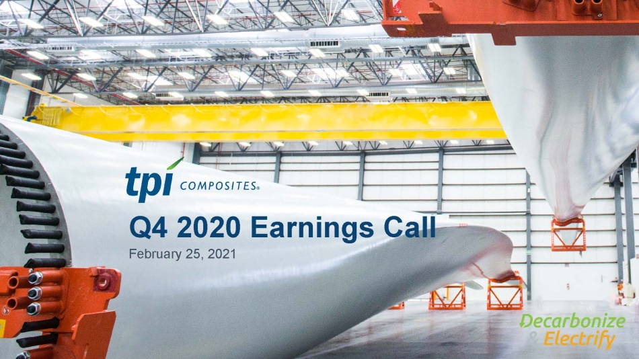
Q4 2020 Earnings Call February 25, 2021

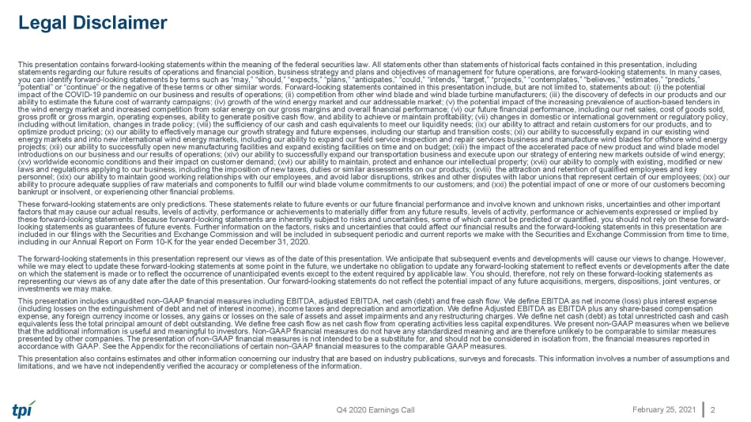
Q4 2020 Earnings Call February 25, 2021 Legal Disclaimer This presentation contains forward - looking statements within the meaning of the federal securities law. All statements other tha n statements of historical facts contained in this presentation, including statements regarding our future results of operations and financial position, business strategy and plans and objectives of m ana gement for future operations, are forward - looking statements. In many cases, you can identify forward - looking statements by terms such as “may,” “should,” “expects,” “plans,” “anticipates,” “could,” “inten ds,” “target,” “projects,” “contemplates,” “believes,” “estimates,” “predicts,” “potential” or “continue” or the negative of these terms or other similar words. Forward - looking statements contained in this pr esentation include, but are not limited to, statements about: (i) the potential impact of the COVID - 19 pandemic on our business and results of operations; (ii) competition from other wind blade and wind blade turbine manufacturers; (iii) the discovery of defects in our products and our ability to estimate the future cost of warranty campaigns; (iv) growth of the wind energy market and our addressable market; (v) the potential impact of the increasing prevalence of auction - based tenders in the wind energy market and increased competition from solar energy on our gross margins and overall financial performance; (v i) our future financial performance, including our net sales, cost of goods sold, gross profit or gross margin, operating expenses, ability to generate positive cash flow, and ability to achieve or maintain pro fitability; (vii) changes in domestic or international government or regulatory policy, including without limitation, changes in trade policy; (viii) the sufficiency of our cash and cash equivalents to meet our li qui dity needs; (ix) our ability to attract and retain customers for our products, and to optimize product pricing; (x) our ability to effectively manage our growth strategy and future expenses, including our startu p a nd transition costs; (xi) our ability to successfully expand in our existing wind energy markets and into new international wind energy markets, including our ability to expand our field service inspection a nd repair services business and manufacture wind blades for offshore wind energy projects; (xii) our ability to successfully open new manufacturing facilities and expand existing facilities on time and on b udg et; (xiii) the impact of the accelerated pace of new product and wind blade model introductions on our business and our results of operations; (xiv) our ability to successfully expand our transportation busi nes s and execute upon our strategy of entering new markets outside of wind energy; (xv) worldwide economic conditions and their impact on customer demand; (xvi) our ability to maintain, protect and enhance ou r i ntellectual property; (xvii) our ability to comply with existing, modified or new laws and regulations applying to our business, including the imposition of new taxes, duties or similar assessments on our pr odu cts; (xviii) the attraction and retention of qualified employees and key personnel; (xix) our ability to maintain good working relationships with our employees, and avoid labor disruptions, strikes and other disputes with labor unions that represent certain of our employees; (xx) our ability to procure adequate supplies of raw materials and components to fulfill our wind blade volume commitments to our cust ome rs; and (xxi) the potential impact of one or more of our customers becoming bankrupt or insolvent, or experiencing other financial problems.​ These forward - looking statements are only predictions. These statements relate to future events or our future financial performa nce and involve known and unknown risks, uncertainties and other important factors that may cause our actual results, levels of activity, performance or achievements to materially differ from any futu re results, levels of activity, performance or achievements expressed or implied by these forward - looking statements. Because forward - looking statements are inherently subject to risks and uncertainties, some of which cannot be predicted or quantified, you should not rely on these forward - looking statements as guarantees of future events. Further information on the factors, risks and uncertainties that could aff ect our financial results and the forward - looking statements in this presentation are included in our filings with the Securities and Exchange Commission and will be included in subsequent periodic and current r epo rts we make with the Securities and Exchange Commission from time to time, including in our Annual Report on Form 10 - K for the year ended December 31, 2020. The forward - looking statements in this presentation represent our views as of the date of this presentation. We anticipate that subsequent events and developments will cause our views to change. However, while we may elect to update these forward - looking statements at some point in the future, we undertake no obligation to update any forward - looking statement to reflect events or developments after the date on which the statement is made or to reflect the occurrence of unanticipated events except to the extent required by applicab le law. You should, therefore, not rely on these forward - looking statements as representing our views as of any date after the date of this presentation. Our forward - looking statements do not reflect the pot ential impact of any future acquisitions, mergers, dispositions, joint ventures, or investments we may make. This presentation includes unaudited non - GAAP financial measures including EBITDA, adjusted EBITDA, net cash (debt) and free cas h flow. We define EBITDA as net income (loss) plus interest expense (including losses on the extinguishment of debt and net of interest income), income taxes and depreciation and amortization. We define Adjusted EBITDA as EBITDA plus any share - based compensation expense, any foreign currency income or losses, any gains or losses on the sale of assets and asset impairments and any restructuring charges. We define net c ash (debt) as total unrestricted cash and cash equivalents less the total principal amount of debt outstanding. We define free cash flow as net cash flow from operating activities less capital expenditures. We present non - GAAP measures when we believe that the additional information is useful and meaningful to investors. Non - GAAP financial measures do not have any standardized meaning and are therefore unlikely to be comparable to similar measures presented by other companies. The presentation of non - GAAP financial measures is not intended to be a substitute for, and should not be considered in isolation from, the financial measures reported in accordance with GAAP. See the Appendix for the reconciliations of certain non - GAAP financial measures to the comparable GAAP mea sures. This presentation also contains estimates and other information concerning our industry that are based on industry publicatio ns, surveys and forecasts. This information involves a number of assumptions and limitations, and we have not independently verified the accuracy or completeness of the information. 2

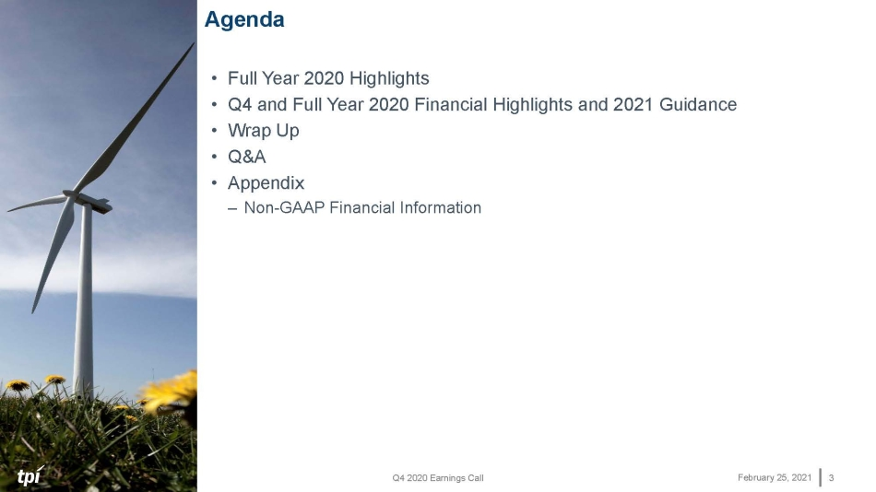
Q4 2020 Earnings Call February 25, 2021 Agenda 3 • Full Year 2020 Highlights • Q4 and Full Year 2020 Financial Highlights and 2021 Guidance • Wrap Up • Q&A • Appendix – Non - GAAP Financial Information

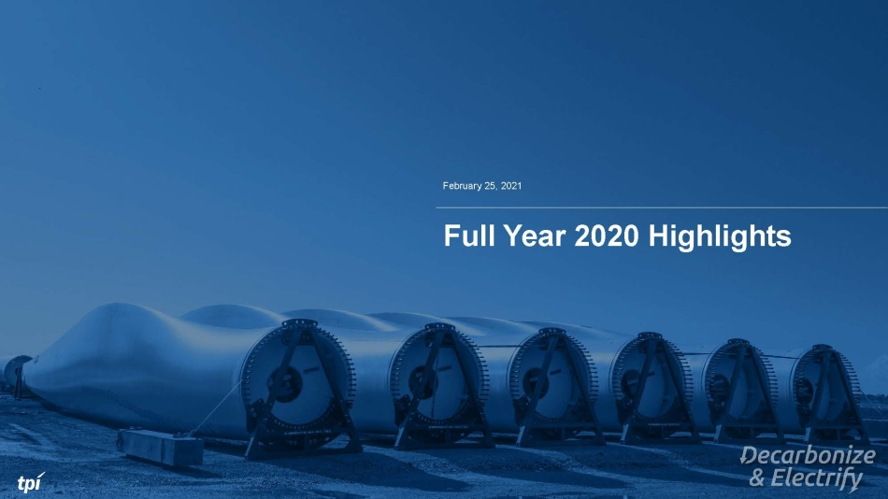
February 25, 2021 Full Year 2020 Highlights

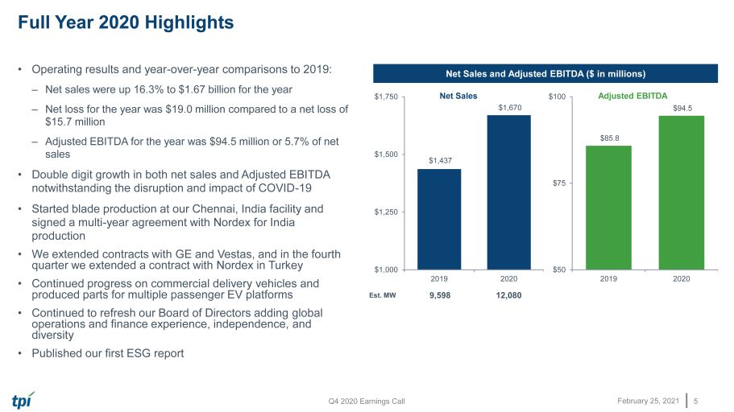
Q4 2020 Earnings Call February 25, 2021 • Operating results and year - over - year comparisons to 2019: – Net sales were up 16.3% to $1.67 billion for the year – Net loss for the year was $19.0 million compared to a net loss of $15.7 million – Adjusted EBITDA for the year was $94.5 million or 5.7% of net sales • Double digit growth in both net sales and Adjusted EBITDA notwithstanding the disruption and impact of COVID - 19 • Started blade production at our Chennai, India facility and signed a multi - year agreement with Nordex for India production • We extended contracts with GE and Vestas, and in the fourth quarter we extended a contract with Nordex in Turkey • Continued progress on commercial delivery vehicles and produced parts for multiple passenger EV platforms • Continued to refresh our Board of Directors adding global operations and finance experience, independence, and diversity • Published our first ESG report Full Year 2020 Highlights 5 Net Sales and Adjusted EBITDA ($ in millions) Est. MW 9,598 12,080 $1,437 $1,670 $1,000 $1,250 $1,500 $1,750 2019 2020 Net Sales $86 $94 $50 $75 $100 2019 2020 Adjusted EBITDA

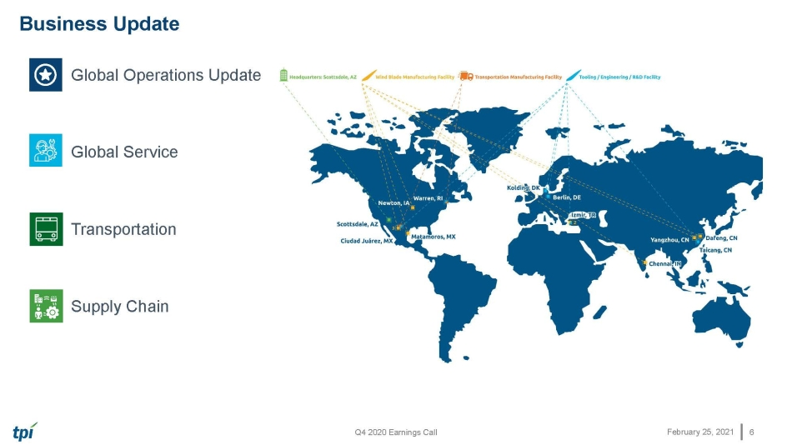
Q4 2020 Earnings Call February 25, 2021 • Global Operations Update • Global Service • Transportation • Supply Chain Business Update 6

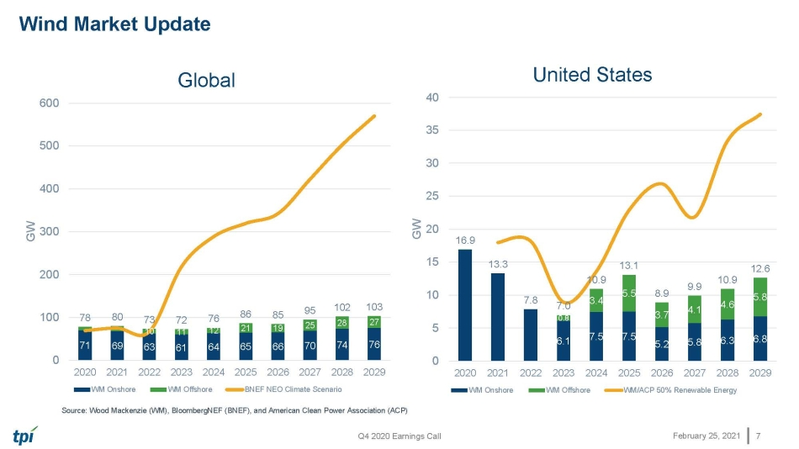
Q4 2020 Earnings Call February 25, 2021 Wind Market Update 7 Source: Wood Mackenzie (WM), BloombergNEF (BNEF), and American Clean Power Association (ACP) 6.1 7.5 7.5 5.2 5.8 6.3 6.8 0.8 3.4 5.5 3.7 4.1 4.6 5.8 16.9 13.3 7.8 7.0 10.9 13.1 8.9 9.9 10.9 12.6 0 5 10 15 20 25 30 35 40 2020 2021 2022 2023 2024 2025 2026 2027 2028 2029 GW United States WM Onshore WM Offshore WM/ACP 50% Renewable Energy 71 69 63 61 64 65 66 70 74 76 10 11 12 21 19 25 28 27 78 80 73 72 76 86 85 95 102 103 0 100 200 300 400 500 600 2020 2021 2022 2023 2024 2025 2026 2027 2028 2029 GW Global WM Onshore WM Offshore BNEF NEO Climate Scenario

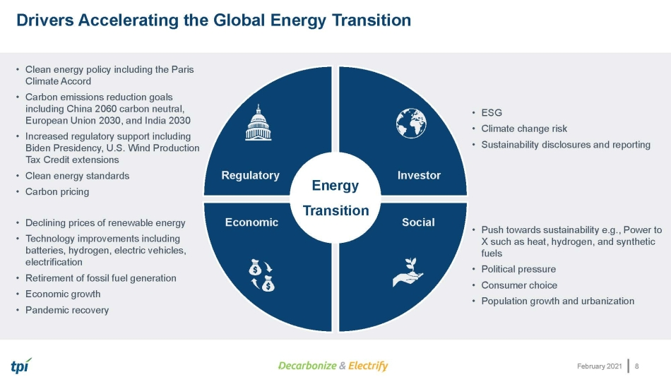
February 2021 Drivers Accelerating the Global Energy Transition 8 • Clean energy policy including the Paris Climate Accord • Carbon emissions reduction goals including China 2060 carbon neutral, European Union 2030, and India 2030 • Increased regulatory support including Biden Presidency, U.S. Wind Production Tax Credit extensions • Clean energy standards • Carbon pricing • Declining prices of renewable energy • Technology improvements including batteries, hydrogen, electric vehicles, electrification • Retirement of fossil fuel generation • Economic growth • Pandemic recovery • ESG • Climate change risk • Sustainability disclosures and reporting • Push towards sustainability e.g., Power to X such as heat, hydrogen, and synthetic fuels • Political pressure • Consumer choice • Population growth and urbanization Energy Transition Investor Social Regulatory Economic

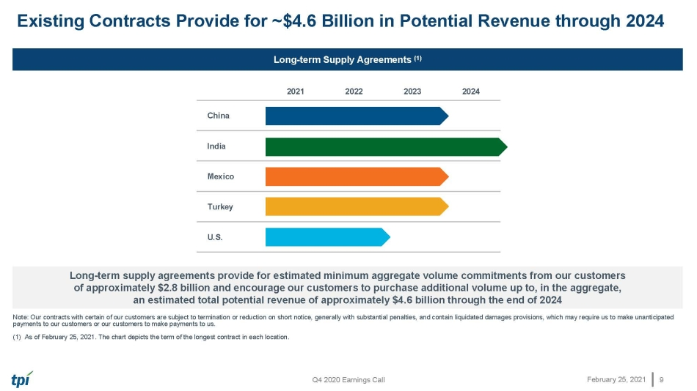
Q4 2020 Earnings Call February 25, 2021 Existing Contracts Provide for ~$4.6 Billion in Potential Revenue through 2024 9 Long - term Supply Agreements (1) Long - term supply agreements provide for estimated minimum aggregate volume commitments from our customers of approximately $ 2.8 billion and encourage our customers to purchase additional volume up to, in the aggregate, an e stimated total potential revenue of approximately $4.6 billion through the end of 202 4 Note: Our contracts with certain of our customers are subject to termination or reduction on short notice, generally with substantial penalties, and contain l iqu idated damages provisions, which may require us to make unanticipated payments to our customers or our customers to make payments to us. (1) As of February 25, 2021. The chart depicts the term of the longest contract in each location . 2021 2022 2023 2024 China India Mexico Turkey U.S.

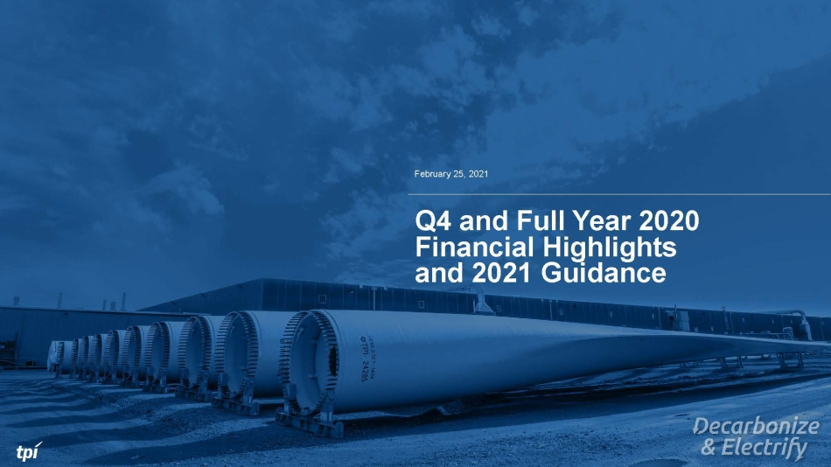
February 25, 2021 Q4 and Full Year 2020 Financial Highlights and 2021 Guidance

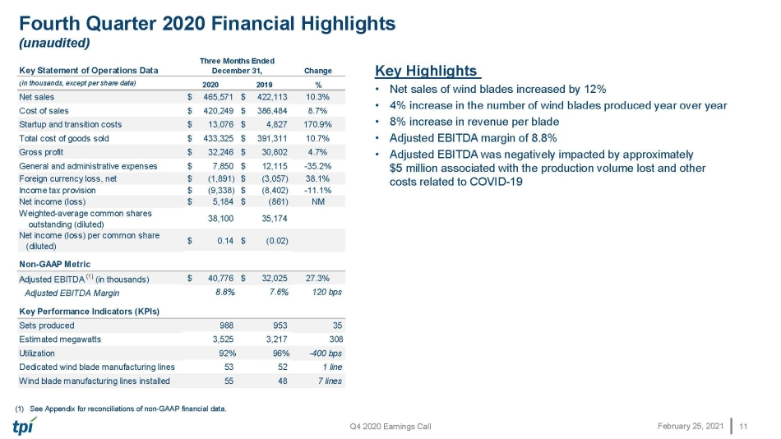
Q4 2020 Earnings Call February 25, 2021 Fourth Quarter 2020 Financial Highlights (unaudited) 11 Key Highlights • Net sales of wind blades increased by 12% • 4% increase in the number of wind blades produced year over year • 8% increase in revenue per blade • Adjusted EBITDA margin of 8.8% • Adjusted EBITDA was negatively impacted by approximately $5 million associated with the production volume lost and other costs related to COVID - 19 (1) See Appendix for reconciliations of non - GAAP financial data. Key Statement of Operations Data Change (in thousands, except per share data) 2020 2019 % Net sales $ 465,571 $ 422,113 10.3% Cost of sales $ 420,249 $ 386,484 8.7% Startup and transition costs $ 13,076 $ 4,827 170.9% Total cost of goods sold $ 433,325 $ 391,311 10.7% Gross profit $ 32,246 $ 30,802 4.7% General and administrative expenses $ 7,850 $ 12,115 -35.2% Foreign currency loss, net $ (1,891) $ (3,057) 38.1% Income tax provision $ (9,338) $ (8,402) -11.1% Net income (loss) $ 5,184 $ (861) NM Weighted-average common shares outstanding (diluted) 38,100 35,174 Net income (loss) per common share (diluted) $ 0.14 $ (0.02) Non-GAAP Metric Adjusted EBITDA (1) (in thousands) $ 40,776 $ 32,025 27.3% Adjusted EBITDA Margin 8.8% 7.6% 120 bps Key Performance Indicators (KPIs) Sets produced 988 953 35 Estimated megawatts 3,525 3,217 308 Utilization 92% 96% -400 bps Dedicated wind blade manufacturing lines 53 52 1 line Wind blade manufacturing lines installed 55 48 7 lines Three Months Ended December 31,

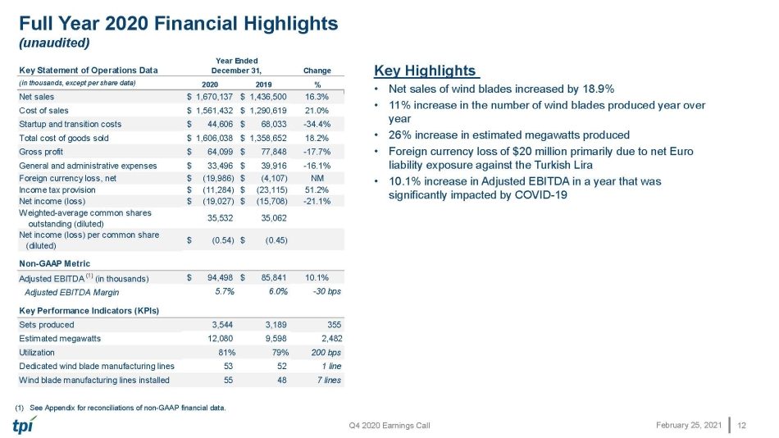
Q4 2020 Earnings Call February 25, 2021 Full Year 2020 Financial Highlights (unaudited) 12 Key Highlights • Net sales of wind blades increased by 18.9% • 11% increase in the number of wind blades produced year over year • 26% increase in estimated megawatts produced • Foreign currency loss of $20 million primarily due to net Euro liability exposure against the Turkish Lira • 10.1% increase in Adjusted EBITDA in a year that was significantly impacted by COVID - 19 (1) See Appendix for reconciliations of non - GAAP financial data. Key Statement of Operations Data Change (in thousands, except per share data) 2020 2019 % Net sales $ 1,670,137 $ 1,436,500 16.3% Cost of sales $ 1,561,432 $ 1,290,619 21.0% Startup and transition costs $ 44,606 $ 68,033 -34.4% Total cost of goods sold $ 1,606,038 $ 1,358,652 18.2% Gross profit $ 64,099 $ 77,848 -17.7% General and administrative expenses $ 33,496 $ 39,916 -16.1% Foreign currency loss, net $ (19,986) $ (4,107) NM Income tax provision $ (11,284) $ (23,115) 51.2% Net income (loss) $ (19,027) $ (15,708) -21.1% Weighted-average common shares outstanding (diluted) 35,532 35,062 Net income (loss) per common share (diluted) $ (0.54) $ (0.45) Non-GAAP Metric Adjusted EBITDA (1) (in thousands) $ 94,498 $ 85,841 10.1% Adjusted EBITDA Margin 5.7% 6.0% -30 bps Key Performance Indicators (KPIs) Sets produced 3,544 3,189 355 Estimated megawatts 12,080 9,598 2,482 Utilization 81% 79% 200 bps Dedicated wind blade manufacturing lines 53 52 1 line Wind blade manufacturing lines installed 55 48 7 lines Year Ended December 31,

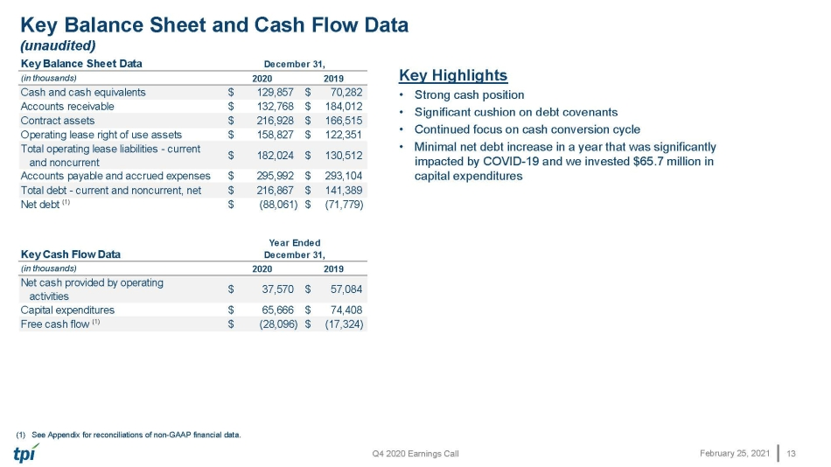
Q4 2020 Earnings Call February 25, 2021 Key Balance Sheet and Cash Flow Data (unaudited) 13 Key Highlights • Strong cash position • Significant cushion on debt covenants • Continued focus on cash conversion cycle • Minimal net debt increase in a year that was significantly impacted by COVID - 19 and we invested $65.7 million in capital expenditures (1) See Appendix for reconciliations of non - GAAP financial data. Key Balance Sheet Data (in thousands) 2020 2019 Cash and cash equivalents $ 129,857 $ 70,282 Accounts receivable $ 132,768 $ 184,012 Contract assets $ 216,928 $ 166,515 Operating lease right of use assets $ 158,827 $ 122,351 Total operating lease liabilities - current and noncurrent $ 182,024 $ 130,512 Accounts payable and accrued expenses $ 295,992 $ 293,104 Total debt - current and noncurrent, net $ 216,867 $ 141,389 Net debt (1) $ (88,061) $ (71,779) Key Cash Flow Data (in thousands) 2020 2019 Net cash provided by operating activities $ 37,570 $ 57,084 Capital expenditures $ 65,666 $ 74,408 Free cash flow (1) $ (28,096) $ (17,324) Year Ended December 31, December 31,

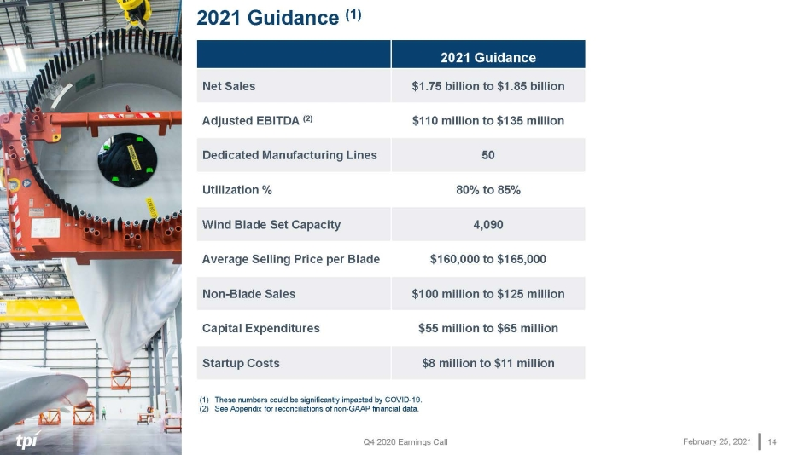
Q4 2020 Earnings Call February 25, 2021 2021 Guidance (1) 14 (1) These numbers could be significantly impacted by COVID - 19. (2) See Appendix for reconciliations of non - GAAP financial data. 2021 Guidance Net Sales $1.75 billion to $1.85 billion Adjusted EBITDA (2) $110 million to $135 million Dedicated Manufacturing Lines 50 Utilization % 80% to 85% Wind Blade Set Capacity 4,090 Average Selling Price per Blade $160,000 to $165,000 Non - Blade Sales $100 million to $125 million Capital Expenditures $55 million to $65 million Startup Costs $8 million to $11 million

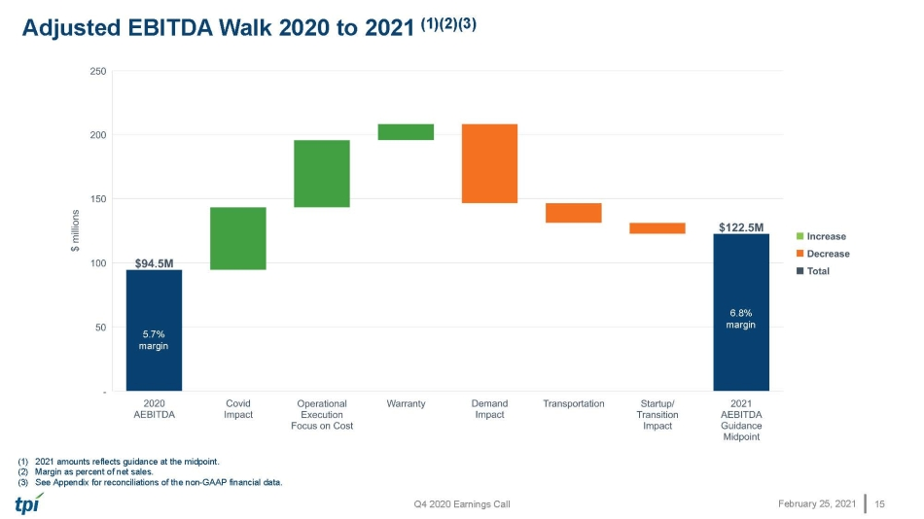
Q4 2020 Earnings Call February 25, 2021 (1) 2021 amounts reflects guidance at the midpoint. (2) Margin as percent of net sales. (3) See Appendix for reconciliations of the non - GAAP financial data. Adjusted EBITDA Walk 2020 to 2021 (1)(2)(3) 15 5.7% margin 6.8% margin 5.7% margin 6.8% margin

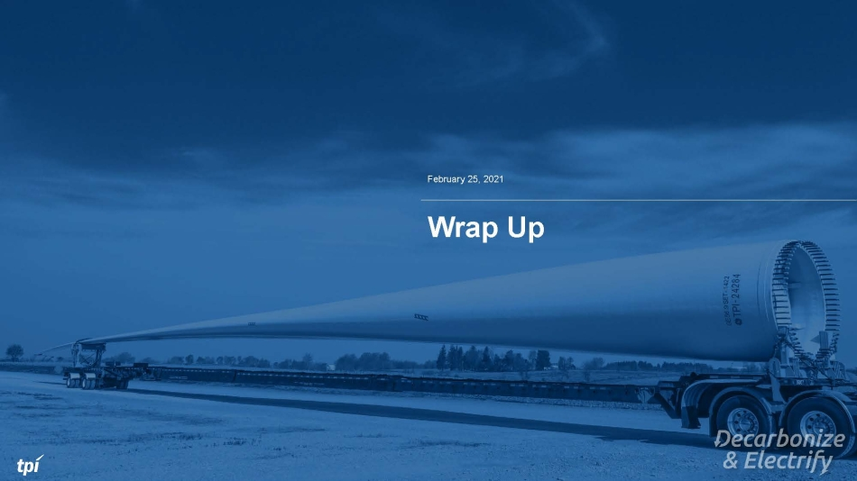
February 25, 2021 Wrap Up

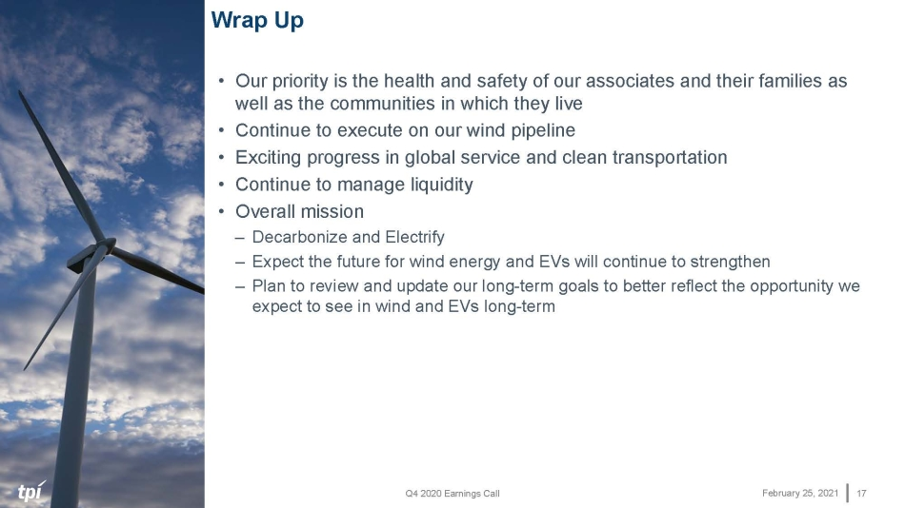
Q4 2020 Earnings Call February 25, 2021 Wrap Up 17 • Our priority is the health and safety of our associates and their families as well as the communities in which they live • Continue to execute on our wind pipeline • Exciting progress in global service and clean transportation • Continue to manage liquidity • Overall mission – Decarbonize and Electrify – Expect the future for wind energy and EVs will continue to strengthen – Plan to review and update our long - term goals to better reflect the opportunity we expect to see in wind and EVs long - term

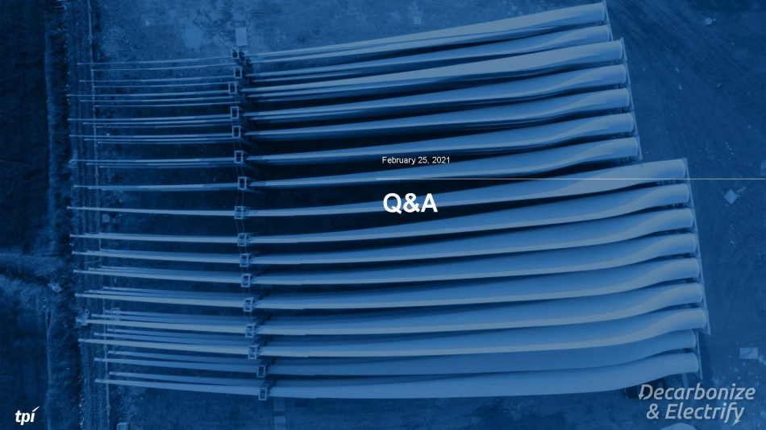
February 25, 2021 Q&A

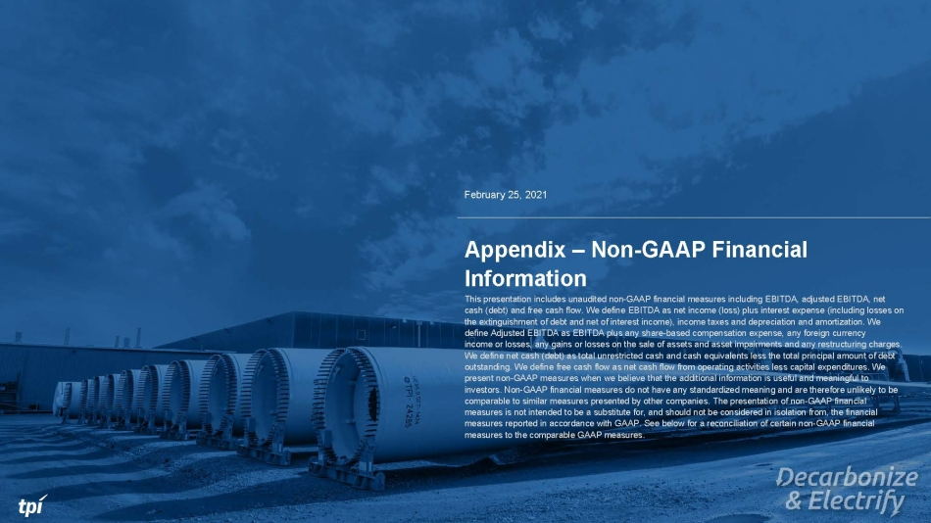
February 25, 2021 Appendix – Non - GAAP Financial Information This presentation includes unaudited non - GAAP financial measures including EBITDA, adjusted EBITDA, net cash (debt) and free cash flow. We define EBITDA as net income (loss) plus interest expense (including losses on the extinguishment of debt and net of interest income), income taxes and depreciation and amortization. We define Adjusted EBITDA as EBITDA plus any share - based compensation expense, any foreign currency income or losses, any gains or losses on the sale of assets and asset impairments and any restructuring charges. We define net cash (debt) as total unrestricted cash and cash equivalents less the total principal amount of debt outstanding. We define free cash flow as net cash flow from operating activities less capital expenditures. We present non - GAAP measures when we believe that the additional information is useful and meaningful to investors. Non - GAAP financial measures do not have any standardized meaning and are therefore unlikely to be comparable to similar measures presented by other companies. The presentation of non - GAAP financial measures is not intended to be a substitute for, and should not be considered in isolation from, the financial measures reported in accordance with GAAP. See below for a reconciliation of certain non - GAAP financial measures to the comparable GAAP measures.

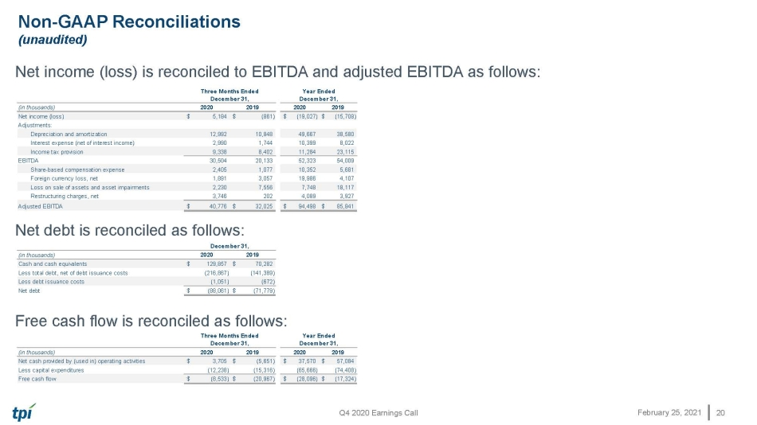
Q4 2020 Earnings Call February 25, 2021 (in thousands) 2020 2019 2020 2019 Net income (loss) 5,184$ (861)$ (19,027)$ (15,708)$ Adjustments: Depreciation and amortization 12,992 10,848 49,667 38,580 Interest expense (net of interest income) 2,990 1,744 10,399 8,022 Income tax provision 9,338 8,402 11,284 23,115 EBITDA 30,504 20,133 52,323 54,009 Share-based compensation expense 2,405 1,077 10,352 5,681 Foreign currency loss, net 1,891 3,057 19,986 4,107 Loss on sale of assets and asset impairments 2,230 7,556 7,748 18,117 Restructuring charges, net 3,746 202 4,089 3,927 Adjusted EBITDA 40,776$ 32,025$ 94,498$ 85,841$ Three Months Ended December 31, Year Ended December 31, Non - GAAP Reconciliations (unaudited) 20 (in thousands) 2020 2019 Cash and cash equivalents 129,857$ 70,282$ Less total debt, net of debt issuance costs (216,867) (141,389) Less debt issuance costs (1,051) (672) Net debt (88,061)$ (71,779)$ December 31, (in thousands) 2020 2019 2020 2019 Net cash provided by (used in) operating activities 3,705$ (5,651)$ 37,570$ 57,084$ Less capital expenditures (12,238) (15,316) (65,666) (74,408) Free cash flow (8,533)$ (20,967)$ (28,096)$ (17,324)$ Three Months Ended December 31, Year Ended December 31, Net income (loss) is reconciled to EBITDA and adjusted EBITDA as follows: Net debt is reconciled as follows: Free cash flow is reconciled as follows:

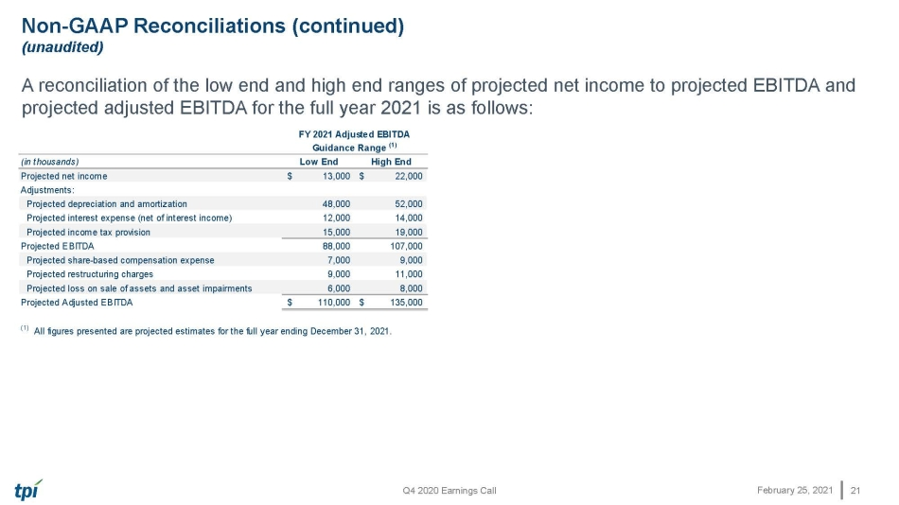
Q4 2020 Earnings Call February 25, 2021 Non - GAAP Reconciliations (continued) (unaudited) A reconciliation of the low end and high end ranges of projected net income to projected EBITDA and projected adjusted EBITDA for the full year 2021 is as follows: 21 (in thousands) Low End High End Projected net income 13,000$ 22,000$ Adjustments: Projected depreciation and amortization 48,000 52,000 Projected interest expense (net of interest income) 12,000 14,000 Projected income tax provision 15,000 19,000 Projected EBITDA 88,000 107,000 Projected share-based compensation expense 7,000 9,000 Projected restructuring charges 9,000 11,000 Projected loss on sale of assets and asset impairments 6,000 8,000 Projected Adjusted EBITDA 110,000$ 135,000$ (1) All figures presented are projected estimates for the full year ending December 31, 2021. FY 2021 Adjusted EBITDA Guidance Range (1)



